SuiteCommerce Standard

Quieren darle Free shipping a items en específico del cart, que están marcados con el checkbox del field custitem185. A los otros del cart, NO. Si el envío tiene varios ítems y algunos que no son free, entonces no va a ser free.

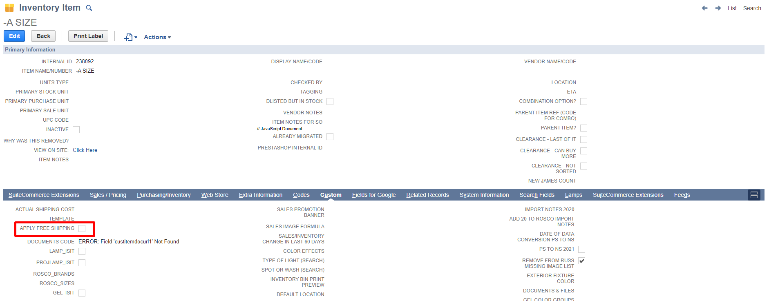

Que esta customización solo aplique a los 48 estados continentales.

Este delivery method no lo utilizan:
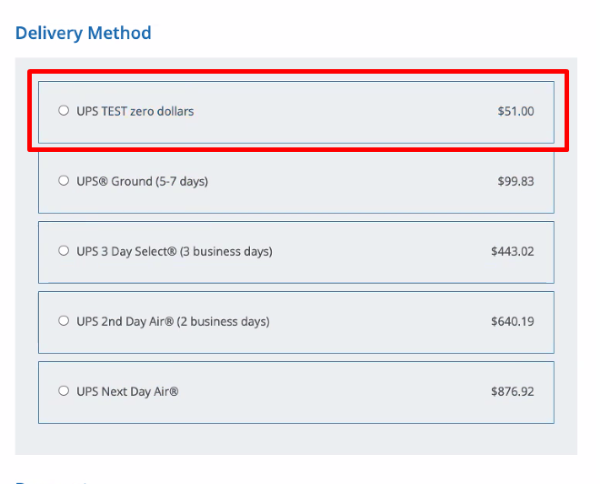

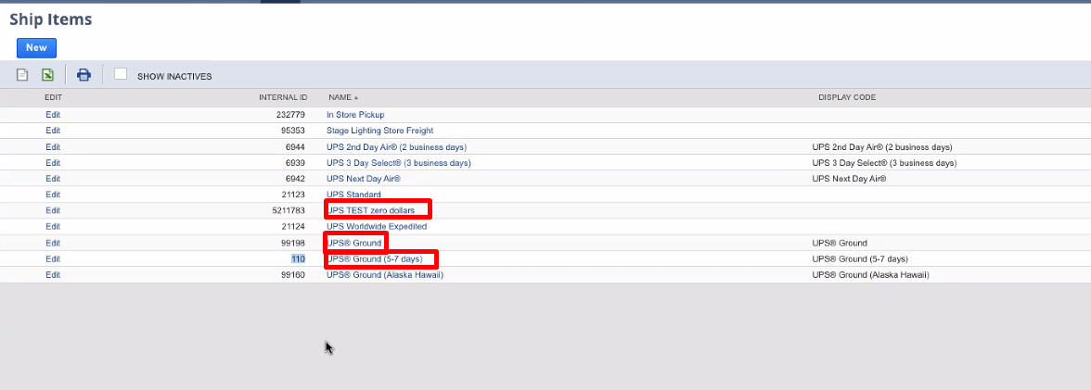
No usan UPS GROUND y UPS TEST Zero dollars (no lo borran porque tienen historia de años de ventas), solo usan UPS GROUND (5-7 days).

Lo que quieren es que UPS Ground (5-7 days) este calculado con los free shipping ítems en 0 y el precio que corresponda (los weights no se mandan a 0). Lo quieren así:
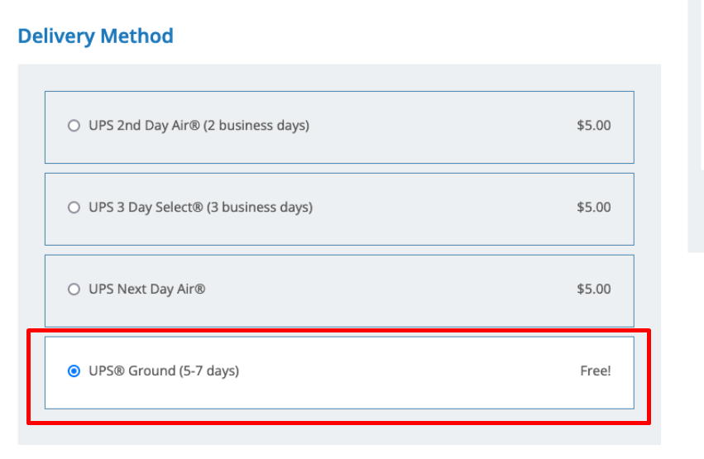
Usar scriptable cart 100%, tiene que haber un método ahí que te ayude, o acceder a datos
No se puede usar lo de AFA porque me da el costo si, pero no puedo cambiar el costo.

The item badge is not doable on suite commerce, because it’s a native extension. Take a look at the native badge code.

Item badge
Make sure that the customization will include this badge, but we should not worry about it.

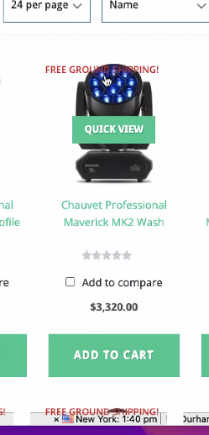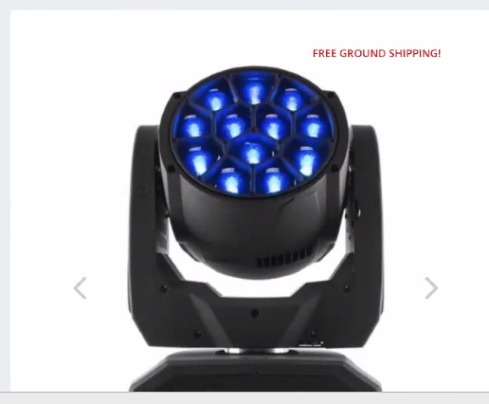

We will need to add that to the cart cause it’s not showing up:
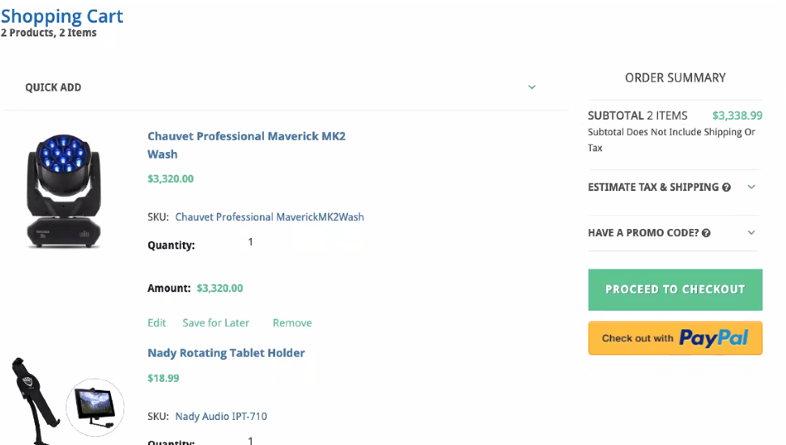

Problemas con que estén mixed los free y los no free

Goal: To provide a singular check box in an item that allows the Stage Lighting Store to give this item Free Ground Shipping at the “Economy” Level independent of any other item that may be in the shopping cart.

Debería mostrarse el checkbox en el item record, no se tiene que mostrar nada en la página.
It will just show 0 price on their checkout for that?

Notes:
To provide this free shipping this button must zero out it’s cost in the shipping calculation and also give the item the free shipping badge for advertising.

Show up zero in the price in cart while doing shipping calculation?
Where do you want this badge? how will it show? Do you have a layout for it?

If there are non free shipping items in the shopping cart it must still reflect a cost associated to the weights and dimensions of those items.

I believe this is the normal pricing as before for regular items, is that correct?

The free shipping option should be choosen as the default at checkout but be able to be changed by the customer or sales rep.

This free shipping button must work in the shopping cart and in the Netsuite environment.
In Sitebuilder, we used the Field ID custitem185. All items we want to have free shipping already have this check box selected.

We do NOT want to offer free shipping based on an order total. But very specifically to the items individually.
We would like this Free Shipping to apply only to the 48 Continental United States.
Customization applies only on the major US states. Is there a way to do this?

It must only apply to a shipping level of “Economy” Shipping – This needs to be created, currently we are using UPS Ground.

Notas
De Pablo:
There is a feature from the commerce API that flags specific lines in the cart to be excluded from shipping calculation.

However, this feature had big issues with performance, since every time a line is excluded, every available shipping option will be recalculated. Besides, if you exclude two lines, you are going to trigger those recalcs two times also (1 recalc per line excluded, there is no way to exclude multiple lines at the same time and then trigger just one recalc).

So, if that’s still the only option available, it is doable in SCA but we are going to experience serious performance issues.

Solución
No se puede hacer lo mismo que en ANGEL FIRE.

Hay que usar scriptable cart:

https://nlcorp.app.netsuite.com/app/help/helpcenter.nl?fid=section_N2554144.html
Se puede usar de este ejemplo, hace un override de setTaxAmount(), entonces podría buscar la función de setShippingCost() y hacerle un override.

function customOnChange(type, name, linenum) {
If (name == ‘promocode’ || name == ‘taxrate’) {
setTaxAmount();
}
}

function customRecalc(type, action) {
if( type == ‘item’) {
setTaxAmount();
}
}

Function setTaxAmount () {
var postArgs = new Array();
postArgs['zipCode'] = nlapiGetField('shipzip');
postArgs['saleTotal'] = nlapiGetField('subtotal');
var response = nlapiRequestURL("http://www.thirdpartytaxcalculator.com", postArgs, null, null);
var body = response.getBody();
var taxRate = body;
nlapiSetFieldValue('taxrate', taxRate, false /*fire field change*/, true /*synchronous*/);
}

https://nlcorp.app.netsuite.com/app/help/helpcenter.nl?fid=section_N2554377.html

Podemos usar SuiteScript para agregar un item gratis a la orden cuando el shopping cart contiene un item identificado como trigger.

USAR un Sample Script que se triggerea cuando el shopping cart tiene un item marcado con el field custitem185.
// customOnChange function will trigger on a FieldChanged client event.
function customOnChange(type, name, linenum) {
if (name == 'promocode') {
bogo('commit');
}
}

function customRecalc(type, action) {
// In SuiteScript for the web store, action can only be 'commit' or 'remove.'
if (type == 'item'){
bogo(action);
}
}

Estas líneas sirven para poner en = el costo de un ítem
nlapiSelectNewLineItem('item');
nlapiSetCurrentLineItemValue('item', 'item', mouseId, true, true);
nlapiSetCurrentLineItemValue('item', 'quantity', impressivoQty, true, true);
setCurrentLineRate(0);

var desc = nlapiGetCurrentLineItemValue('item','description');
nlapiSetCurrentLineItemValue('item','description', desc+' (FREE)', true, true);
desc = nlapiGetCurrentLineItemValue('item','description');
debug('New description is '+desc);
nlapiCommitLineItem('item');
}

// If the BOGO coupon is no longer valid, and the shopping cart contains the free mouse and
// the Impressivo computer, remove the free mouse.
if (!promoEnabled && action == 'commit' && impressivoQty > 0 && freeMouseLine > 0)
{
debug('Selecting free mouse line');
nlapiSelectLineItem('item', freeMouseLine);
debug('Deleting free mouse on line '+freeMouseLine+' because of change in promo code');
nlapiRemoveLineItem('item', freeMouseLine);
}

Dynamic discount:
https://nlcorp.app.netsuite.com/app/help/helpcenter.nl?fid=section_N2557130.html

Otra opción es crear un item de descuento y de ahí descontarle al shipping

nlApiSetLineCurrentValue(item, attribute, valor, true, true)
Dynamic Discounts
Create a discount item for applying the discount to web orders.
You will reference this discount item in your script. The advantage of using this approach is that the discount is subtracted from the total amount in the cart, so the order subtotal is consistent between the cart and the order confirmation page. Also, the shopper can override the discount by entering a promotion code. This approach is used in the sample script provided here.
Agregar el descuento cuando el item es field tanto
var filter = new nlobjSearchFilter('custrecord_currencyid', null, 'is', currencyId);
Buscar el field de seteado en shipping 0
var column = new nlobjSearchColumn('custrecord_discount_threshold');
Obtener id del producto
var searchresults = nlapiSearchRecord('customrecord_threshold', null, filter, column);
Obtener así la query

Gift wrap:
https://nlcorp.app.netsuite.com/app/help/helpcenter.nl?fid=section_N2557809.html

Crea un item field y además tiene un script donde lo triggerean los shoppers mediante marcar el item para un regalo, me sirve esto.

function customOnChange(type, name, linenum)
{
if (name == 'promocode')
{
setFreeShipping();
}
}

function customRecalc(type, action)
{
// On the web store, action can only be 'commit' or 'remove'.
if (type == 'item') {
setFreeShipping();
}
}

function setFreeShipping()
{
var currencyId = nlapiGetFieldValue('currency');
//get value of shipping method
//get value of customrecord item field

// Obtengo el valor de todos los ítems, y de ahí me fijo si tienen free shipping o no
var numlines = nlapiGetLineItemCount('item');
debug('numlines = '+numlines);
for (var i=1; i <= numlines; i++) {
var itemId = getVal('item', i);
var relatedItemId = getVal('custcolgiftwrapitemid', i);
var isFreeShipping = getVal('custcolgiftwrapcost', i);

//o custcolgiftwrapped que es el checkbox
}

Time-Based Promotions:
// Override the current price with the discount price.
setCurrentLineRate(discountPrice);

// This function will update the rate and also recalculate the correct value for amount.
function setCurrentLineRate(rate)
{
nlapiSetCurrentLineItemValue('item', 'rate', rate, true, true);
var qty = parseInt(nlapiGetCurrentLineItemValue('item', 'quantity'));
var amount = qty * rate;
nlapiSetCurrentLineItemValue('item', 'amount', amount, true, true);
}

Setting Default Location for Web Orders

// Get entire quantities of all inventoried items in the sales order. Note that optional filtering
// criteria is used when calling the getItemMap() function to exclude noninventory items.

var itemMap = getItemMap('NonInvtPart');
var numLines = nlapiGetLineItemCount('item');

// Get available quantities for each location of each item on the order.
for (itemId in itemMap)
{
debug('Loading record for item id '+itemId);
var rec = nlapiLoadRecord('inventoryitem', itemId);
debug('Item record '+itemId+' loaded - getting location count');

Ultimate guide

Brief introduction
With Scriptable Cart, SuiteCommerce developers can use SuiteScript to invoke client scripts on the sales order form used for website orders.
At its most basic, Scriptable Cart is a single SuiteScript file that you deploy to your NetSuite instance that executes when a sales order is created on the Commerce website or in the backend UI.
Scriptable Cart works by listening to events in the client and then performing actions when those events are triggered. Entre ellos, los eventos que escuchan son:
- Recalc: After shopping cart contents are changed. An item is added or removed or a quantity is changed
- ValidateLine

Validate line
A validateLine event occurs when a line in a transaction changes. This change can occur when a shopper adds an item, changes an item's quantity, or removes an item.
In all cases, validateLine functions run before a change is made, making them the perfect mechanism for a wide range of preventative actions. For example, you can write a function to prevent shoppers from adding a particular item to their cart or to prevent shoppers from increasing the quantity of a particular item over a certain amount.
Because functions like these are checking certain conditions, they must return a value of true or false. (Returning no value is interpreted as false). Returning true allows a change to happen, while a value of false blocks the change. The return value of each function called from customValidateLine must be tested. If any function returns false, processing must stop and return false.

Use this custom function to link to the ValidateLine event. Note that all validations occur in the item list on the shopping cart page. For best results, filter out any events that are not executed against items.

Recalc
Event occurs after the shopping cart changes.
Example actions:
- when a shopper adds an item to the shopping cart, the ‘recalc' event is triggered, and the order amount is recalculated (commit)
- when a shopper deletes an item from the cart, the ‘recalc' event is triggered and the order amount is recalculated (remove)
- when the quantity of an item changes in the shopping cart, the ‘recalc' event is triggered and the order subtotal is recalculated (commit)

https://nlcorp.app.netsuite.com/app/help/helpcenter.nl?fid=section_N2553048.html

Use Scriptable Cart when the customization you need cannot be accomplished by developing an extension or by customizing SuiteCommerce or SCA. Se usa para:
- Queres correr el Código de una customización en Commerce website y la UI.
- Necesitas modificar el item rate

El script de UI de Netsuite corre con permisos de administrador, mientras que el script de Scriptable Cart corre con permisos de Customer Center o Shopper. (1)
No podes disparar alertas en Scriptable Cart.
Las funciones son llamadas mucho mas frecuentemente con Scriptable Cart, lo que puede impactar negativamente en la performance.

Podes enviar información a Scriptable Cart desde SC o SCA para que triggeree alguna función y que corra. Se puede hacer mediante un custom transaction body o un column field, donde seteas la información que precisas de SC o SCA, y luego llamas a este field en el script de Scriptable Cart (en este caso, el field item185 que usamos).

Primer paso
Para prender Scriptable Cart:
- An administrator must enable the following features: Advanced Site Customization, and Client SuiteScript:
  - Setup > Company > Enable Features.
  - On the Enable Features page:
    - Select the Web Presence tab and check the Advanced Site Customization box to enable the feature.
    - Select the SuiteCloud tab and check the Client SuiteScript box to enable the feature.
After you have turned on the required features:
- go to Commerce > Websites > Website List (Administrator) and click Edit next to your website name. Click setup tab:
  - Check the Scriptable Cart and Checkout box

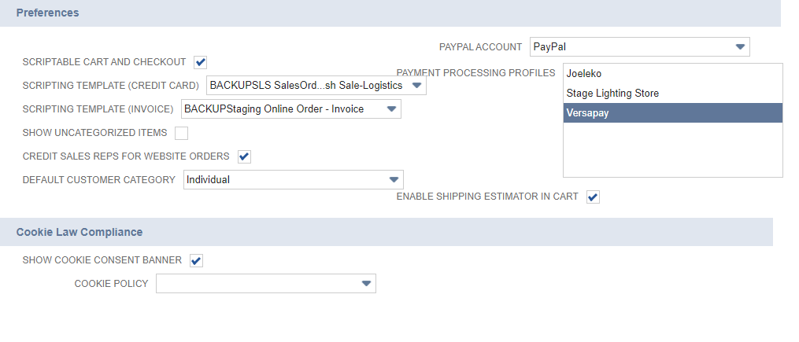

Create a new client script
Creo una carpeta de nombre ScriptableCart o lo que quiera, luego dentro de ella creo un archivo exampleScriptable.js, y le agrego:
function debug (message) {
nlapiLogExecution('DEBUG', 'Example Scriptable Cart', message);
}

function customRecalc () {
debug('recalc called!');
}

function customValidateLine (type) {
if (type = 'item') {
var itemId = nlapiGetCurrentLineItemValue('item', 'item');
debug('Line validated: ' + itemId);
}
return true;
}

Ir a Customization -> Scripting -> Scripts, creo uno nuevo y agrego el file desde mi computadora.
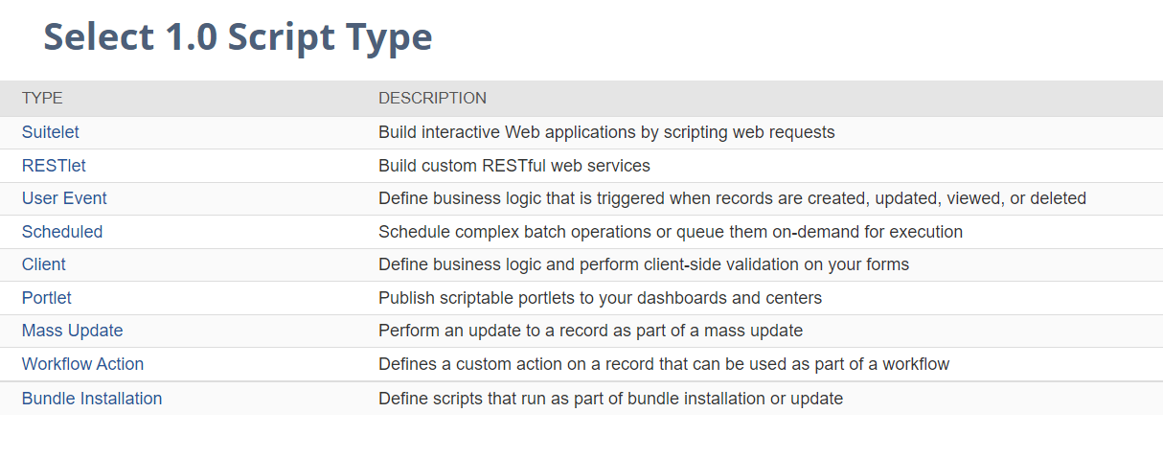
Elijo Client acá.
Luego, On the Script page, enter or set the following:
- Name: Example Scriptable Cart
- ID: _example_scriptable_cart
- Scripts tab -> Recalc Function field: customRecalc.
- In the Validate Line Function field: enter customValidateLine.
- In the pageInit Function enter: customPageInit.
- In the save Record Function enter: customSaveRecord. (Podemos agregar un custom field a nuestra orden con esto).
- Deployment tab
  - Applies To: Sales Order
  - Status: Released

Todos los roles,
Web store, web application y Other.

Aprieto Save & Deploy.
On the Audience subtab of the script deployment record, make sure that Customer Center is selected. (1)
https://nlcorp.app.netsuite.com/app/help/helpcenter.nl?fid=article_80082826669.html

Agregar cosas para probar con saveRecord que es un bloqueante
Like the validateLine function, the saveRecord function can be used as a blocker. This means a user can complete all the steps to submit a sales order and then you can run business logic to check whether the order should go through. In this use case, the business logic validates the order.

Ejemplo creado freeShippingScriptable.
https://nlcorp.app.netsuite.com/app/help/helpcenter.nl?fid=article_1141046782.html
Tener cuidado con:
You created a variable called freeshipping_item, so when you update the record for this script in NetSuite, you need to reference the method names using this name. For example, instead of simply entering recalc in the record's Recalc Function field, you need to enter freeshipping_item.recalc, because these are being returned by the function.

Testing
Para testear esto:
- Go to your Commerce website and either add an item to the cart or change the quantity of an item already in the cart. Remember, the recalc function is called when the contents of the cart change therefore these changes should invoke your script.
- To check the script execution log for the message generated by your script, go to: Customization > Scripting > Scripts.
- Find your script, Example Scriptable Cart, in the list and click View.
- In the Execution Log tab, check for the Debug message from the script: recalc called!

Para testear customPageInit:
- Go to your Commerce website, sign out, and then add one or more items to the shopping cart.
So, let’s trigger this. On the frontend of your site, sign out, and then add an item to your cart. Visit the execution log and you should see the messages you added before, as well as the new one. Now, in the backend, go to create a new sales order. After the page has finished loading, refresh the execution log and you’ll see the other message in your conditional.
- Go to Customization > Scripting > Scripts to check the script execution log for the messages generated by your script.
- In the Execution Log tab, check for messages like these from the new function you added to the script: You're in the frontend!.
- In NetSuite, create a new sales order.
- Go back to the execution log for your script, refresh the log, and check for messages like these: You're in the backend!

Para testear customSaveRecord:
- Go to your Commerce website, and place an order.
- In NetSuite, look up that order.
- Go to the Custom tab for the order and verify that the custom field contains the value defined by the script.

Segundo paso

Checkout forms vs shopping forms
Los shoppers en el web store van a usar una shopping form y durante el checkout una checkout form. Se puede usar la misma transaction form para ambos propósitos.
- La shopping form es transistoria, contiene una orden mientras los customers están comprando en el sitio. Tu Script de suiteScript esta attacheado a esta shopping form, y luego usado como un scripting template.
- Pero cuando el cliente hace submit de su orden en NetSuite, lo hacen con la checkout form. Esta checkout form permanece en el sistema.
Entonces, durante una compra, los datos son pasados de la shopping form a la checkout form, la checkout form se guarda en la base de datos, y hay que asegurar que esos campos de la shopping form se correspondan a los campos de la checkout form.

Para setear las checkout forms y shopping forms:
- Ir a Setup -> Transactions -> Transaction forms
  - Set up your shopping form for the Scriptable Cart: Customize a sales order form by attaching a client script, and then entering the functions on the Custom Code subtab. If you use terms for invoicing some customers, you must attach your script to both types of sales order forms: cash sale and invoice.
  - Set up your checkout form: Identify an existing sales order form or create a customized internal sales order form for use as the checkout form.
- Go to Commerce > Websites > Website List (Administrator) to specify the forms you want to use on your web store for both shopping and checkout.

ESTO ES DE SITE BUILDER NO SIRVE
  - Specify the shopping form: On the Setup subtab, select the sales order form with your script attached in one or both of the Scripting Template fields.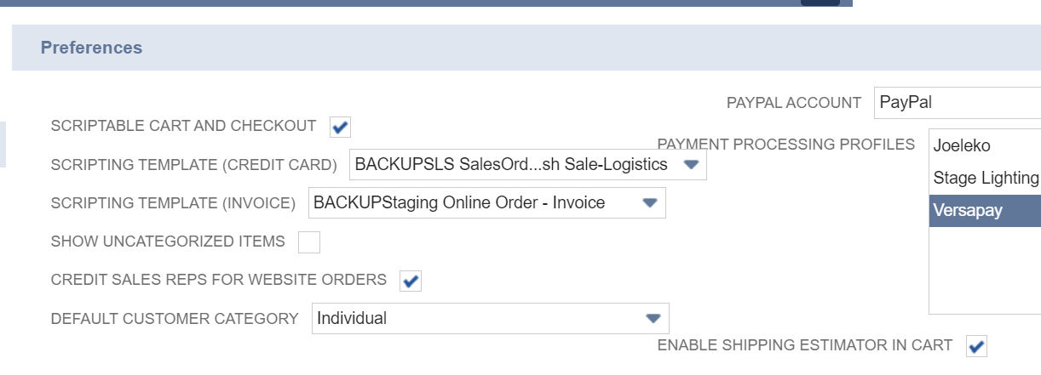Based on the sales order form you select as a Scripting Template, your custom script executes against data in the shopping cart.

  - Specify the checkout form: Click the Shopping subtab. In the Checkout Preferences section, select the sales order form (or forms) you created in Step1b 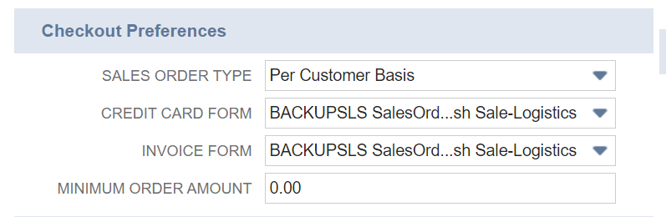The forms you select on the Shopping subtab of the Setup Web Site page in the Checkout Preferences section determine the forms on which shoppers submit their web orders. You cannot select external forms for this purpose.
- Click Save.

Then you attach this new client script to a customized sales order transaction forms, it can be any of the following, y luego tenes que agregar las funciones en el custom code subtab:
- Standard Sales Order – Invoice
- Standard Sales Order - Cash Sale
- Standard Online Sales Order - Invoice (External)
- Standard Online Sales Order - Cash Sale (External)

El próximo paso es select the forms, you want to use in the Scripting Template (Credit Card), and Scripting Template (Invoice) fields, para esto:
Select the newly created sales order forms as the Scriptable Template for your web store.
- Go to Commerce > Websites > Website List (Administrator).
- Click Edit next to your website name.
- In the Preferences section, set the Scripting Templates for your site:
  - Scripting Template (Credit Card) – Select your customized Sales Order - Cash Sale form.
  - Scripting Template (Invoice) – Select your customized Sales Order - Invoice form.

Deploy
To deploy a script in the shopping cart:
Go to Customization > Forms > Transaction Forms.
- Customize a Standard Sales Order - Invoice, and a Standard Sales Order - Cash Sale form.
- After you create the two new forms, make a note of their Internal IDs.

https://nlcorp.app.netsuite.com/app/help/helpcenter.nl?fid=section_N2553295.html#question_N2553515

https://nlcorp.app.netsuite.com/app/help/helpcenter.nl?fid=article_0151255693.html

https://nlcorp.app.netsuite.com/app/help/helpcenter.nl?fid=section_N2553295.html#question_N2553515

Solución final
No existe un campo para poner en 0 la línea del item de las sales order (mirando en la sublista ítems del record browser de sales order), entonces busco otra línea que me pueda servir, hay una que se llama excludefromraterequest.
Lo que se puede hacer es cancelar el pedido de calculo de shipping para ciertos ítems, en vez de ponerlos en 0, es mejor. Escribir una linea de request a los Carrier para no pedirles el precio.

La función field changed se ejecuta cuando un campo es modificado por un customer o por un script, en address line modification.
O recalc que es usada cuando los shopping cart contents son cambiados.
Entonces, en recalc, obtengo el shipping method
O en fieldChanged (probar cual de las dos)
Obtengo el ship method (que es el campo shipmethod de la sales order, el primero del record browser shipmethod:
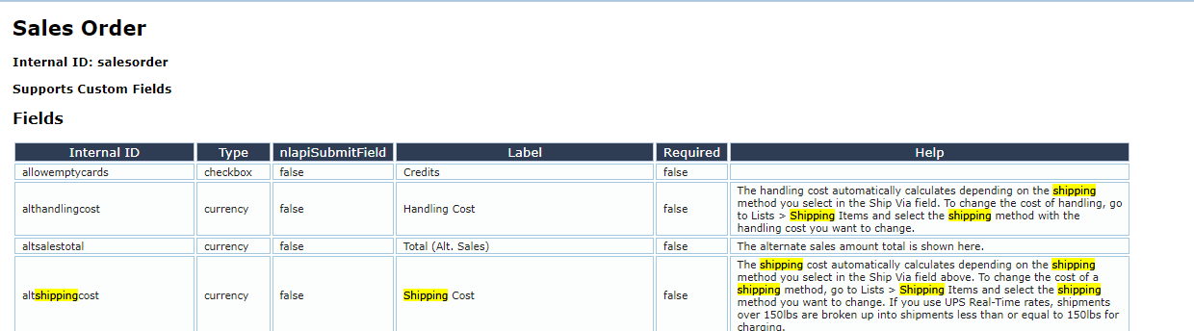

https://nlcorp.app.netsuite.com/help/helpcenter/en_US/srbrowser/Browser2021_2/script/record/salesorder.html)

Si es el de UPS 5-7, ahora entonces me fijo:
Busco algún campo que me pueda servir en una de las sublists de sales order. Esta sublist se llama item, que va a corresponder a cada una de las líneas de las sales order que son ítems, porque las sales order ordenes con líneas de ítems.

Hay un campo que se llama excludefromraterequest que me puede servir para sacar el calculo del shipping method:
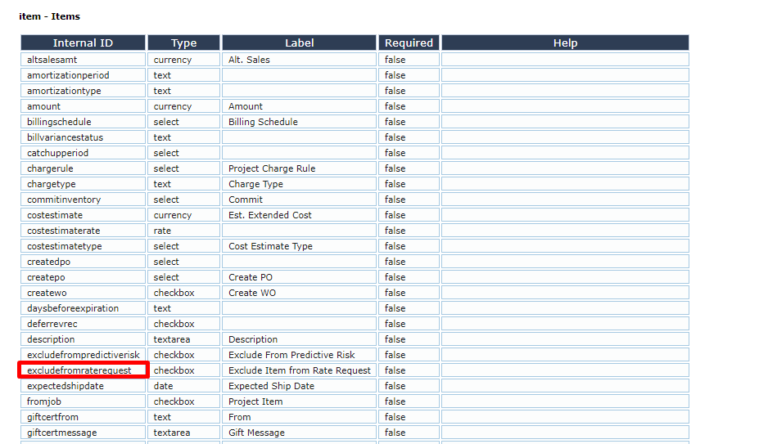
Seteo este field en true para este line item (se hace llamando a la función setLineItem)
https://nlcorp.app.netsuite.com/help/helpcenter/en_US/srbrowser/Browser2021_2/script/record/salesorder.html

En la función field changed o recalc (cuando se eligió el método, esto es cuando cambio un valor, no se si cuando arrancó también se ejecuta esta función, yo supongo que sí)

Cuando la orden cambia el ship method (y me elijen el método que yo quiero, en este caso el de UPS 5 o 7, tengo que mirar el shipping method que me viene de la orden, ejecuta fieldChanged o ejecuta recalc, y si es el shipmethod DE LA ORDEN que quería, luego tengo que setear para la línea del item: excludefromraterequest.

User event vs Client script: client script ejecuta.
User evento ejecuta luego de que se seteo la orden en el before submit o after submit. El client script se usa para todo lo que son cambios antes de setear una orden, si no existe una orden aún.

No vamos a hacer lo de scripting template porque no lo necesitamos, esto se usaba en site builder nomas

Cada vez que modifique el script en backend, agregarle el parámetro a la web store ckinvalidate=T.

Ver diferencias client script y user event.
Ver bien lo que es una sales order.

https://nlcorp.app.netsuite.com/app/help/helpcenter.nl?fid=section_N3042487.html#bridgehead_N3050265

Problema loop infinito
When creating scripts that provide the ability to watch a field for a change, and then write back to the field that changed, a risk of creating an infinite loop exists as follows:
- The Client script watches for fieldA to change.
- fieldA changes.
- The script writes to fieldA, causing the Field Changed event to fire, returning the code to step 2, and this loop repeats indefinitely.
To prevent this looping behavior, you can set the optional firefieldchanged parameter in your client scripts.
The firefieldchanged parameter is available for all write functions. If set to true, the parameter causes any field changed events to fire as normal. This is the default setting. If set to false, field changed events are NOT fired.

Luego:
nlapiSetLineItemValue(type, fldnam, linenum, value)
Sets the value of a sublist field on the current, new record. This API can be used in beforeLoad user event scripts to initialize sublist line items, but only on new records and only on non-stored sublist fields. If you execute this API on an existing record, nothing will happen.
Note that this API is supported in user event scripts only.
This function can be used in client SuiteScript, but note that it is supported only on custom fields and the Description field. If you use this function to set the value of a standard, built-in line item field, the function will not execute.

Error nlapiLoadRecord en Scriptable Cart

No podemos hacer un nlapiLoadRecord porque scriptable cart corre con roles de customer center y de shopper, no de admin, entonces hay que hacer un truco para poder correrlo, y es agregar a la sales order el campo del item.
Entonces lo que vamos a hacer es agregar a cada línea de la sales order, es decir la línea de item, el campo nuevo, esto se puede hacer mediante agregar un transaction line field:

Transaction line field is one per line item.
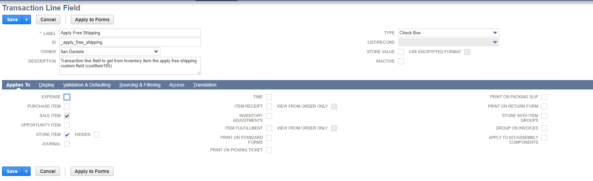
Solo para SALE ITEM y STORE ITEM, y el tipo es checkbox, el mismo que viene del inventory item (custitemfield185).

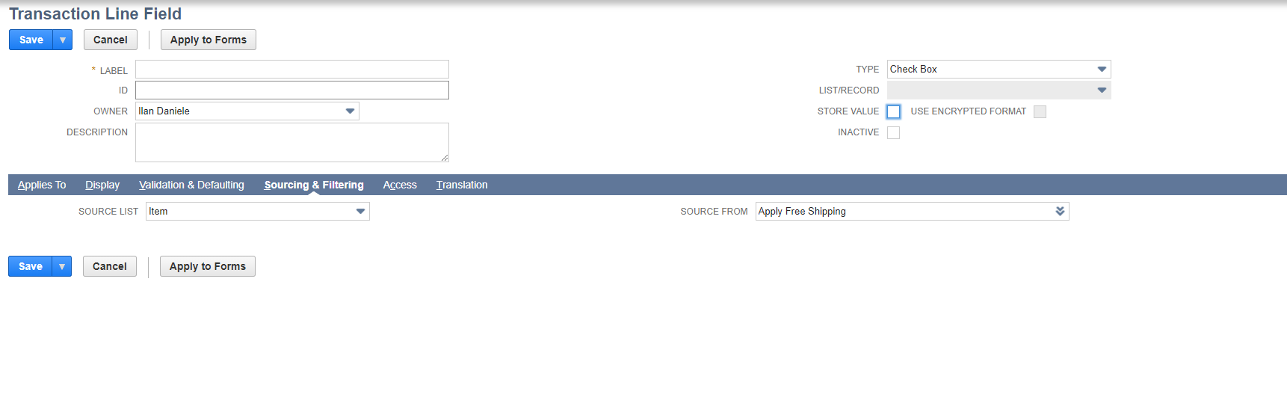
Para agregarlo, debo completer el campo de source list: item y sourcing from: el campo que creamos custom en el item.

Tengo que hacer el apply to forms??

